CULTURAL GEOGRAPHY
HANDOUT PACKET EXAM THREE
Development, Agriculture, Industry,
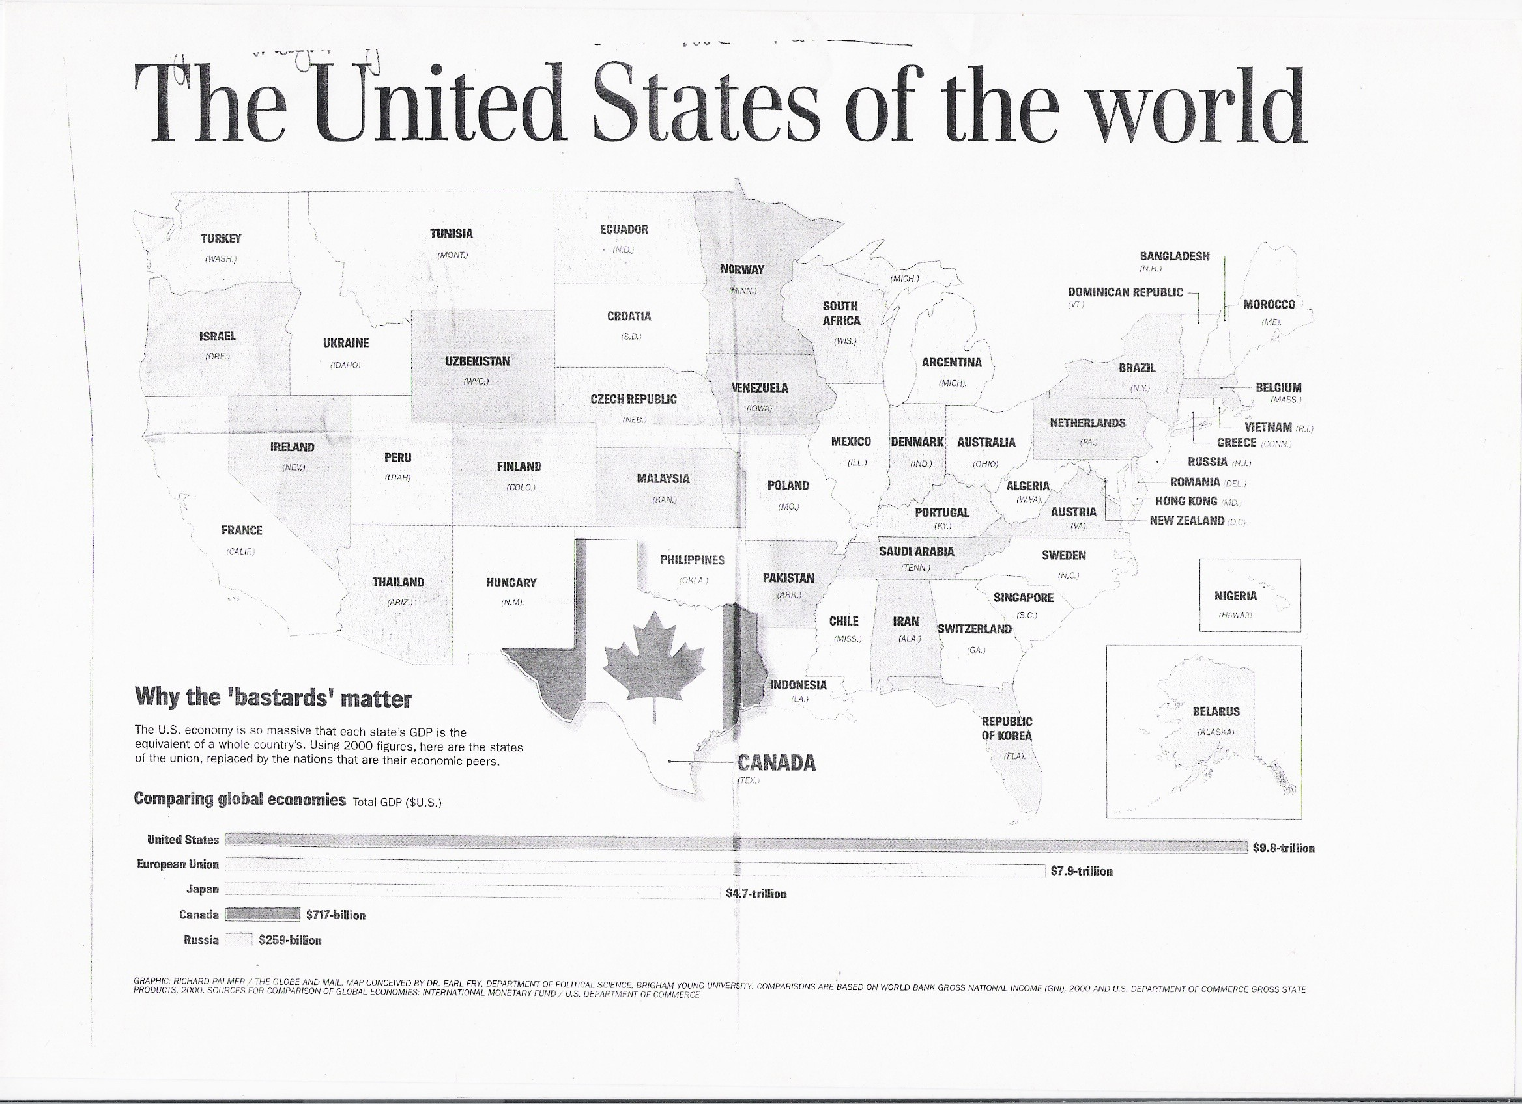
Services, Urbanization and Resource issues

Geography of Development: Regional Review
REGION (HDI score) | CULTURE (Language/Religion) | POPULATION CHARACTERISITICS | “DEVELOPMENT FORMULA”
REGION (HDI score) | CULTURE (Language/Religion) | POPULATION CHARACTERISITICS | “DEVELOPMENT FORMULA”

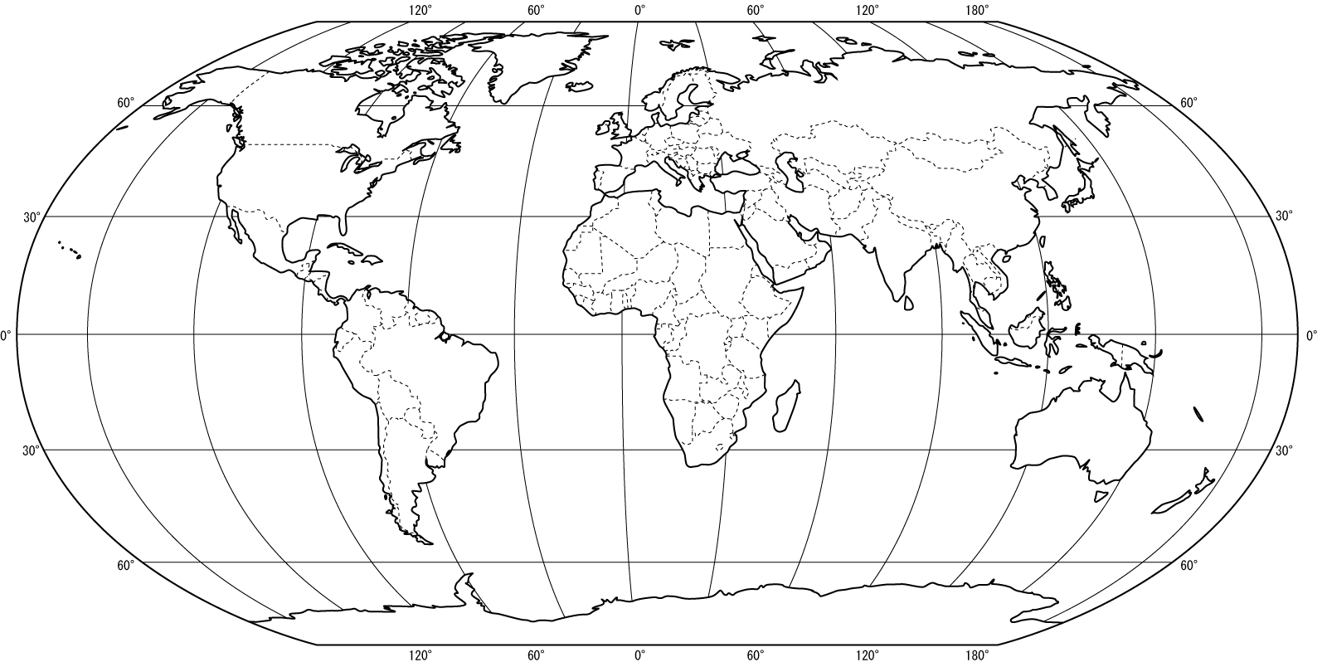
World Agricultural Regions
TYPE | LOCATION | CHARACTERISTICS | Other issues
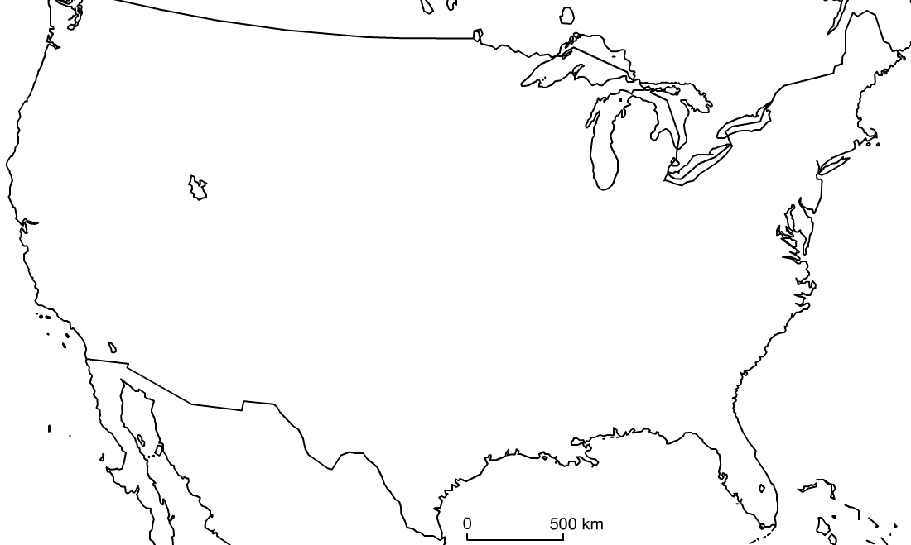
United States Agricultural Regions
LOCATION | TYPE | CHARACTERISTICS
 |  | FARM AREA USE
Urban Populations
1.
2.
3.
4.
5.

COLORADO RIVER COMPACT (_______)
ALLOCATIONS:
1) UPPER BASIN STATES: _________

2) LOWER BASIN STATES: _________

3) __________________ _________
4) __________________ _________
5) Annual loss to ______________ _________
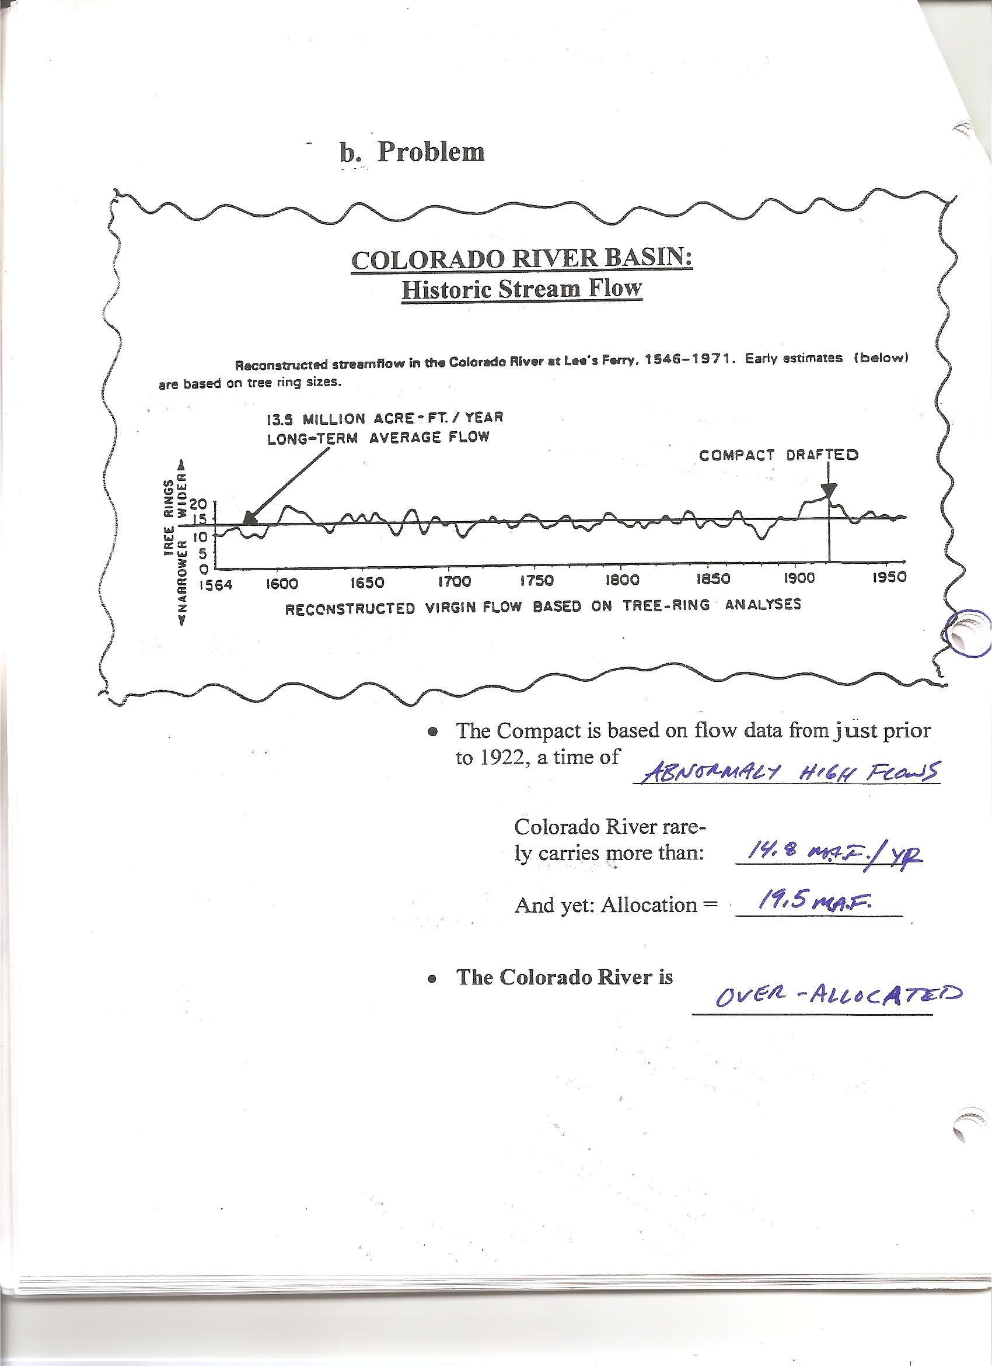
TOTAL ALLOCATION: _________
The Compact (signed in 1922) is based on flow data during a time of _____________________
Colorado actual river flow rarely exceeds ___________So the river is ____________________!
REVIEW QUESTIONS FOR EXAM THREE
DEVELOPMENT
1. What is development? How do geographers study it?
2. Explain the economic indicators geographers examine to determine a country’s level of development (GDP, Types of jobs, worker productivity, raw materials, consumer goods). Explain how each of these indicates development; what do the spatial patterns of these economic indicators look like.
3. What is not measured in the above economic indicators?
4. Explain the social indicators geographers examine to determine a country’s level of development (education/literacy, health and welfare). Explain how each of these indicates development; what do the spatial patterns of these economic indicators look like.
5. Explain the demographic indicators geographers examine to determine a country’s level of development (life expectancy, infant mortality, crude birth rate, natural increase rate). Explain how each of these indicates development; what do the spatial patterns of these economic indicators look like.
6. How is gender related to development? Where do gender inequalities exist? How is gender development measured? (explain GDI, GEM)
7. What is the human development index? Which factors contribute to it?
8. What does the world spatial distribution of development look like? (where are MDCs/LDCs found?)
9. What are some of the reasons we explained for underdevelopment in the LDCs?
10. What is dependency theory?
11. What are the more developed regions of the world? What are the general and individual characteristics of these regions?
12. What are the less developed regions of the world? What are the general and individual characteristics of these regions?
13. What is the development trend today?

14. What are some of the solutions offered to develop less developed countries?
Explain the self-sufficiency approach and problems associated with it.
Explain the international trade approach and some problems associated with it.
15. Explain Rostow’s Development model. Where do current societies fit into it?
16. What types of organizations promote international trade? How do they promote it? What do their critics say?
17. What organizations provide loans to help spur development? What’s the problems with them? What are structural adjustment programs?
18. What is the fair trade model?
19. What is Micro credit?
POVERTY AND AMERICA
1. How has the distribution of wealth in America changed in the past 20 years?
2. What is poverty in America (poverty line)?
3. How has poverty in America changed since the 1960’s?
4. Why is poverty prevalent in the areas that it is?
5. Which are the groups most at risk of poverty?
AGRICULTURE, INDUSTRY AND SERVICES
1. What is the occupation/activity that most of the world works in?
2. What are the three agricultural revolutions? Explain each in detail.
3. What are the differences between agriculture in more developed countries and in less developed countries? (purpose, % farmers, machinery, farm size, related businesses, etc.)
4. How is agriculture related to climate and development?
5. Explain in detail the different types of agriculture practiced in less developed countries:
Shifting Cultivation
Rice paddy/intensive subsistence agriculture
Nomadic herding
Plantation farming
Urban agriculture
6. Explain in detail the different types of agriculture practiced in more developed countries:
Mixed crop and Livestock, Grain farming, Agribusiness
Livestock ranching
Dairy farming
Mediterranean/market garden agriculture
7. Explain some of the challenges facing farmers both in more developed countries and less developed countries.
8. Explain why hunger continues to exist in the world and explain some of the solutions proposed to increase the amount of food produced.
9. What was the industrial revolution? Where did it originate? And where and why did it diffuse to which places first?
10. Explain the differences between a primary, secondary and tertiary industry.
11. What types of factors influence the distribution of industry? (provide some examples of these factors).
12. Where do we find major industry located throughout the world (why these four regions) and where do we find industry located throughout the United States (why these regions)?
13 How has industry changed from the 20th century to today?
14. What is time space compression?
15. Where is industry moving to/expanding (internationally and within the US)? What is a Maquiladora?
16. What are the different types of SERVICES?
17. What determines where services are located?
18. What is the central business district? What is and is not located there?
19. Which types of services are moving to less developed countries and why?
URBAN GEOGRAPHY
1. Explain the different ways to define an “urban area” (legal, urbanized, functional)
2. What is the world wide urbanization trend? How does urbanization differ in MDCs and LDCs?
3. For what reasons have cities been important historically?
4. Explain the different models explaining the development, usage and patterns of cities
Concentric zone model
Sector model
Multiple Nuclei model
How does these relate to San Diego?
5. Compare European, American and Latin American Cities. Why do each look the way they do?
6. Explain the many American inner city problems we spoke of.
7. What is gentrification?
8. What is decentralization? What one factor spurred decentralization more than any other? What kinds of government policies encouraged decentralization?
9. What types of problems have been created by decentralization/suburban sprawl?
Resource Issues
1. What is a resource? What’s the difference between renewable and non-renewable?
2. Explain where the energy in fossil fuels comes from. What are the limitations of fossil fuels?
3. How is the global energy consumption shifting? How much fossil fuels are left?
4. What types of renewable resources maybe alternative? Explain how they provide energy and some of the pros and cons of each.
5. What is pollution?
6. What type of environmental problems does the atmosphere face? Explain these.
7. What types of problems does the hydrosphere face? Explain these (you should use local examples whenever possible).
8. What types of “land based” problems did we speak about? Explain these.
9. Explain in detail what “global warming” is. Make sure you truly understand the idea and have cleared up any previous misconceptions.
10. Explain the following in regards to global warming 1. Evidence for, 2. Controversial areas, 3. What skeptics say.
11. Explain some of the environmental problems facing California.

